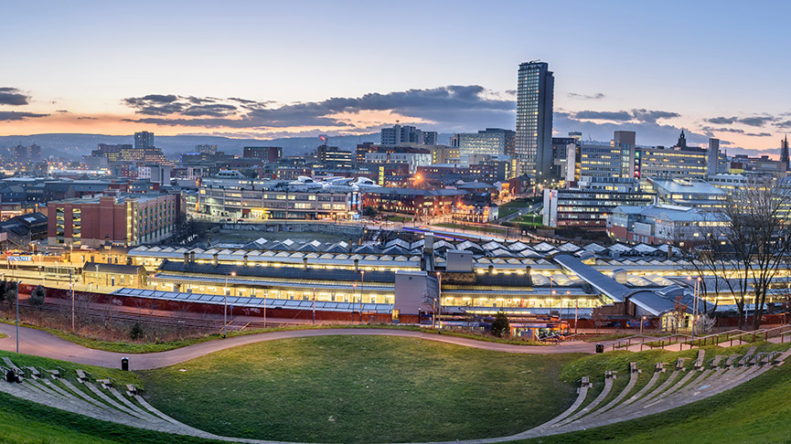
Loxley School

Y6 Staff & Parents Communication Sheet

Dear Parent,

The following information will help you support your child’s learning this half term (Spring 1) in their class with Mrs Taylor.

Details of work covered this half term:

Literacy | Descriptive stories: Year 6 will be retelling the short video “Broken:Rock,Paper, Scissors” and developing descriptive and speech writing.  Non-Chronological reports: Year 6 will be writing about fire and crime safety following their trip to crucial crew.
Maths | Decimals, percentages and fractions: Year 6 will be recapping how to convert between these three as well as finding percentages of amounts.  Algebra: We will be starting to use algebra within calculations to find the missing number.
Science | Classification: Year 6 will be learning about how living things can be sorted into categories and more about micro-organisms.
Topic  History | Settlements: Year 6 will be finding out about how settlements (villages, towns and cities) grow and change. They will be learning about the different requirements of different settlements and about land use.
R E | Humanism: Year 6 will be learning about Humanist beliefs and how people live their lives according to Humanist views.
PSHE | Citizenship: Children will be focusing on caring for others, discrimination and prejudice and diversity.
Computing | Digital art: Year 6 will be looking at the work of Ian Mitchell and using sketch.io to produce similar art.
PE | The children will be working on their Basketball skills
Music | Composition: Year 6 will be using keyboards to build chords and compose their own short pieces to create a mood
Homework | Spellings – Spelling test every Wednesday (spellings on spellingshed).  Homework– To be returned by Monday and new homework issued.  Reading books – To be returned every Monday to be swapped. Please fill in the reading record about the questions and bring the record book back even if the reading book is not finished.
Boosters | Year 6 booster groups are starting this term – check you know when your child’s sessions are.
Trips | Crucial crew (PSHE/Writing trip) – 19th January

