Our Learning this half term…

|  |  |
| --- | --- |
| Reading | Short texts – Finishing Stone Goblins story. Song and Verse: Roald Dahl, Mount Vesuvius Fact File |
| Writing | Gladiator story, Holiday brochure: Italy, Recount: Castleton |
| Maths | Length & perimeter, fractions, multiplication and division facts |
| Science | Plants |
| Geography | Italy – physical and human features |
| History | Finishing off our topic of the Romans |
| RE | Religion, family and community: Prayer, Judaism and Islam |
| Art | Clay and drawing Roman architecture |
| Computing | Controlling on screen models |
| PE | Gymnastics & Net/court/wall games |
| French | CGP core unit 2 |

Home Learning

Reading books – To be returned every **Monday** to be swapped. If children are still reading the same book then books may remain at home but reading record sheets **need** to be returned weekly. Reminder letters will be issued by the Year 3 team, with 3 non-returns being reported to Mr Connolly.

Spellings – The term’s spellings are stuck in the homework books. Spelling tests will take place on Fridays.

Times tables – Times table tests take place on Wednesdays. Please continue to support your child with these at home. TT Rockstars is great to use!

Homework task –Every Monday the children will be set a maths task in their homework book to complete. Hand in day: Friday

**Moving Monsters**

If you would like to take home your moving monster, please donate £1 via Squid to contribute a donation towards the syringe and tubing costs. Many thanks.

**Dates for your diary:**

**Castleton Residential:** 18th – 19th March

**Parents’ evening:**

Tuesday 26th March

Thursday 28th March

**World Book Day**: Wednesday 13th March, come dressed as a word!

**LSFA Easter egg hunt**: Wednesday 27th March

**Break up for Easter holidays:**  Thursday 28th March

**Our reading text this term is:**

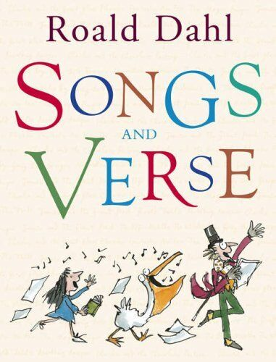

Spring term: half term 4

***Year 3 Parent Communication***

