Loxley Primary School- Reception  Curriculum Overview for parents | 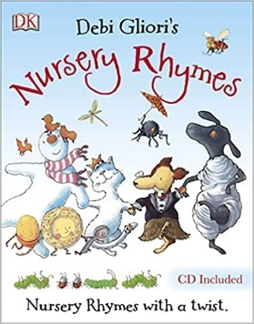  Literacy – Writing  - Continue to work on pencil grip and practise the correct formation of letters  - Use simple story mats to support us with our spelling.  - Write one or two short sentences with a capital letter at the start, finger spaces between words and a full stop at the end.  - Begin to write our own stories. | Literacy – Reading  - Use their phonic knowledge to read real and nonsense words.  - Continue learning Set 2 vowel digraphs and trigraphs  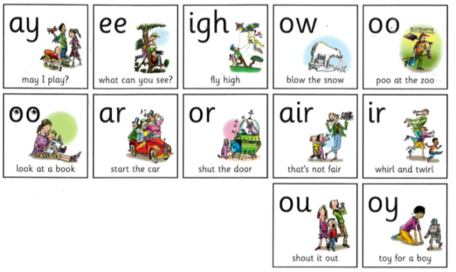  - Read the tricky words learnt so far and new words for this half term: the of me no he I my for you said here are go to be your come where baby all her I’m by they
Communication and Language
- Build up vocabulary related to our learning (see Knowledge Explorer)
- Listen to, sequence and retell traditional stories - The Three Little Pigs, Jack and the Beanstalk, The Three Billy Goats Gruff and Handa’s Surprise.
- Focus on structure of stories, discussing the beginning, middle and end.
- Discuss story language and repetitive phrases in the stories we read.
- Retell stories using puppets and small world settings.
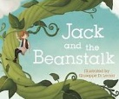
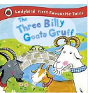
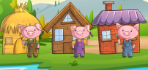
Summer Term 1: Once upon a time
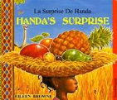

Mathematics  - Use everyday words to describe position: behind, in front of, between, beside, above, below.  - Develop automatic recall of number bonds to 5, and then 10  - Understanding the ordinality of numbers – for example that on a number track, 11 comes after 10 and before 12.  - Understanding the cardinality of numbers – the amount of things a number represents  - Understand and use a range of vocabulary when adding and subtracting: more, less, add, plus, subtract, take away  - Explore, name and describe the properties of 2d and 3d shapes.  - Visualise and describe positions, using positional language. | Personal, Social and Emotional Development  - During health week, learn about the importance of teeth cleaning and a healthy lifestyle, including diet.  - To participate and persevere in sport’s day activities. We will be talking about celebrating their own, and others’, achievements.  - Going for Goals! Set simple goals and persevere to work towards them.  Discuss at home: What is perseverance? | Expressive Arts and Design  - Learn about Vincent Van Gogh and his paintings.  - Paint and draw from observation and imagination.  - Explore colour mixing further, to create tints and shades.  - Re tell traditional stories.  - Listen to Prokoviev’s ‘Peter and the Wolf’.  - Design and make homes and bridges for story characters.  - What is an orchestra? Learn about the four groups of instruments that make an orchestra.  - Listen to, rehearse and perform musical stories – please keep an eye out for an invitation to come and watch our musical performance of The Three Billy Goats Gruff!
Physical Development  - Develop and practice skills with pencils, brushes, scissors and other tools.  - Focus on pencil skills and correct number and letter formation.  - Athletics – take part in track and field games, including simple team races.  - Begin to understand why exercise is important for good health, and talk about exercise and activities we take part in outside of school. | How can you help?  Phonics homework will continue to be sent home on Mondays. Please keep practising all the letters and digraphs (special friends) we have covered so far.  Please practise set 4 tricky words and any words your child does not know from set 1, 2 and 3.  Read and retell stories at home, with a particular focus on repeated phrases. Why not pop a video on See Saw for a special show and tell? | Understanding the World  - Explore plants and growth  - Investigate life cycles and notice new life in the natural world: lifecycle of frogs and butterflies.  - Talk about the lives of people around them, their roles in society and occupations.  - Learn about different places of worship in Sheffield  - Explore materials and their properties

