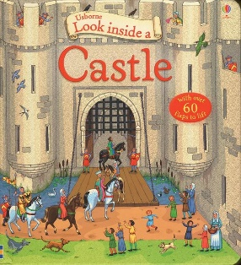

Our Learning this half term…

|  |  |
| --- | --- |
| Reading | **Sir Scallywag and the Battle of Stinky Bottom** and non-fiction books about Castles  Phonics - Daily sessions in groups as well as whole class sessions focussing on Set 3 sounds (oa, ew, ire, ear, ure) green decodable words and red ‘tricky’ words. |
| Writing | **Sir Scallywag and the Battle of Stinky Bottom** – a **character description** using adjectives. **non-chronological** **report** about Castles. Handwriting – sitting letters on the line, correct size and orientation – water letters |
| Maths | **Complete Addition and Subtraction to 10** – subtraction by finding the part, crossing out, using a number line, fact families  **Place value to 20** (count to 20, make numbers to 20 e.g using tens frame, tens and ones, ‘teen’ numbers, 1 more 1 less, using a number line to 20 , estimating and comparing. |
| Science | **Seasonal changes Winter** – weather, trees, day length, clothing, animals (hibernation, migration, nesting) |
| Geography | Not covered this half term |
| History | **Castles** – Why were castles built, when were castles built, inside a castle, who lived in castles and what were their jobs, banquets and tournaments? |
| RE | **Myself – How do we care for others**. The Good Samaritan, The Boy who cried Wolf, Who am I and where do I belong? |
| DT | Complete evaluation of **Moving Pictures** |
| Art | **Painting of a tree in Winter** (spaced learning) Drawing- Paul Klee, self-portraits, animals |
| Computing | **Bee-Bots** – Create a simple programme to control a floor robot and to predict the outcome of simple programs |
| PE | **Games** - Ball skills Dance ? |
| Music | **Exploring pitch – playing percussion instruments, singing songs related to castles, composing music for a castle banquet and listening and identifying changes in pitch in a variety of musical pieces** |

**Dates for your diary:**

**Thurs 25th Jan – Y1 Trip to Conisbrough Castle**

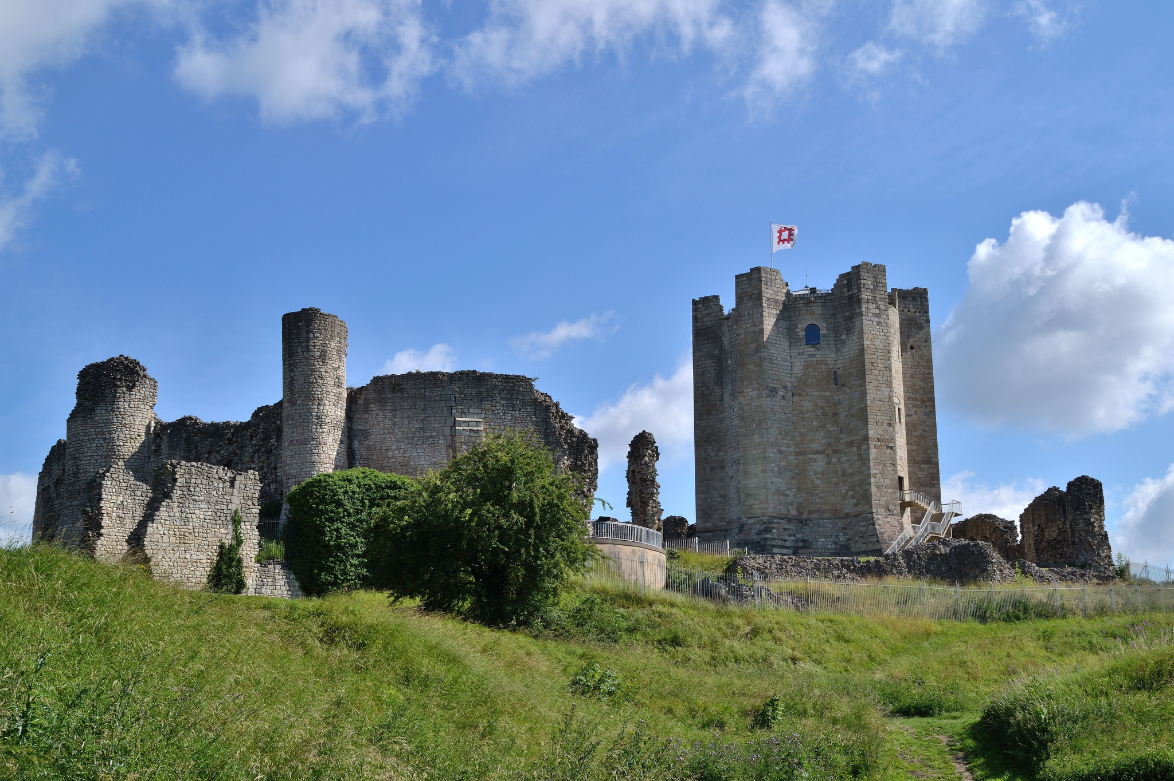

Friday 9th Feb – French day

**Our reading texts this term are :**

**Sir Scallywag and the Battle of Stinky Bottom**

**Books about Castles**

Home Learning

Reading books – Daily reading. To be returned every **Monday** with home reading record book. Reminder letters will be issued by the class teacher and with 3 non-returns being reported to Mr Connolly.

Half-term 3 Red Tricky Words

Weekly Phonics homework based on Set 3 sounds

Weekly Spellings

**Outside of the classroom …**

**Y1 : Art Club – Monday 3.30- 4.30**

**Multi Skills Tuesday 3.30- 4.30**

Recorders

Spring term: Half-Term 3

***Year 1 Parent Communication***

