**Home Learning**

Reading books – To be returned every **Monday** to be swapped. If children are still reading the same book then books may remain at home but reading record sheets **need** to be returned weekly. Reminder letters will be issued by Mr Eaton, with 3 non-returns being reported to Mr Connolly.

Spellings: New spellings on a **Friday** and the test will be the following **Friday**. These will be on EdShed to practice, and also include a short word activity task to complete in homework books.

Maths: TT Rockstars for 30 minutes.

**Outside of the classroom …**

**Times Tables Rockstars**: *Mrs Taylor* (drop in, Fri Lunch)

**Homework:** *Mrs Taylor* (Thursday lunch, as needed)

**Table Top / Board Games & Warhammer Painting**: *Mr Eaton (Mon 3.20 – 4.30)*

**Mixed Football**: *Mr Nuttall* (Wed 3.20 – 4.30)

**Art Club:** *Mrs Torrington* (Thu 3.20 – 4.30)

**The Hut:** *Mrs Torrington & Miss Vickers* (Mon, Tue and Fri lunch)

**Cross-Country:** Various venues, see Mr Nuttall for details.

**Dates for your diary:**

*See clubs sheet for extra curricular details!*

1st November: Caking Night Community Day

Friday 10th November – trip to Loxley

Cemetery for Remembrance Activities

Bikeability course 11th – 15th Dec

Friendship Week 11th – 15th Dec

Last day of term Friday 22nd Dec

**Our** **Learning this half term…**

|  |  |
| --- | --- |
| Reading | **Completion of The Explorer text (2 weeks)**  **Comprehension skill practice focussing specifically around inference and word retrieval**  **A Christmas Carol** – last week before Christmas holidays |
| Writing | **The Sheffield Blitz**: newspaper report  **Lemony Snicket: The Bad Beginning** (later on in term)  **Writing in the style of an author**: using Lemony Snicket as a stimulus. |
| Maths | **Multiplication and division:** Using formal and mental methods  **Statistics:** Using and drawing line graphs and timetables  **Perimeter and area:** Revision on these skills |
| Science | **Materials and how they change:** Identifying the properties of different materials including density, magnetism and conduction. Evaluating the benefits of using different materials. Changes – investigating changeable and non-changeable reactions. Understanding the differences between solids, liquids and gases and how they can change. |
| History | **Remembrance & World War II (integrated into English)**  An insight into Remembrance today and also what life was like on the Home Front in WWII. |
| RE | **What is the religious meaning of Christmas:** Children will learn about the significance of Christmas to Christians and investigate how traditions and symbolism link to the birth of Jesus. |
| Art | **Spout Cottage & Loxley Cemetery Remembrance Art Work** |
| Computing | **Audio**: The children will be learning to sound edit using audacity after recording their folk carol performances. |
| PE | **Athletics**: Children will be working on skills and playing full games. This will be outside PE – please provide children with trousers and a jumper for PE  **Gymnastics** |
| Music | **Clarinets with Mr Martin**  **Folk Carols from our area with performance at Carols in the Woods** |
| French | **All About Ourselves** |

Subjects in black will be taught by Mr Eaton, red will be taught by Mrs Torrington and purple by Mr Nuttall

**Our class reader later this term is:**

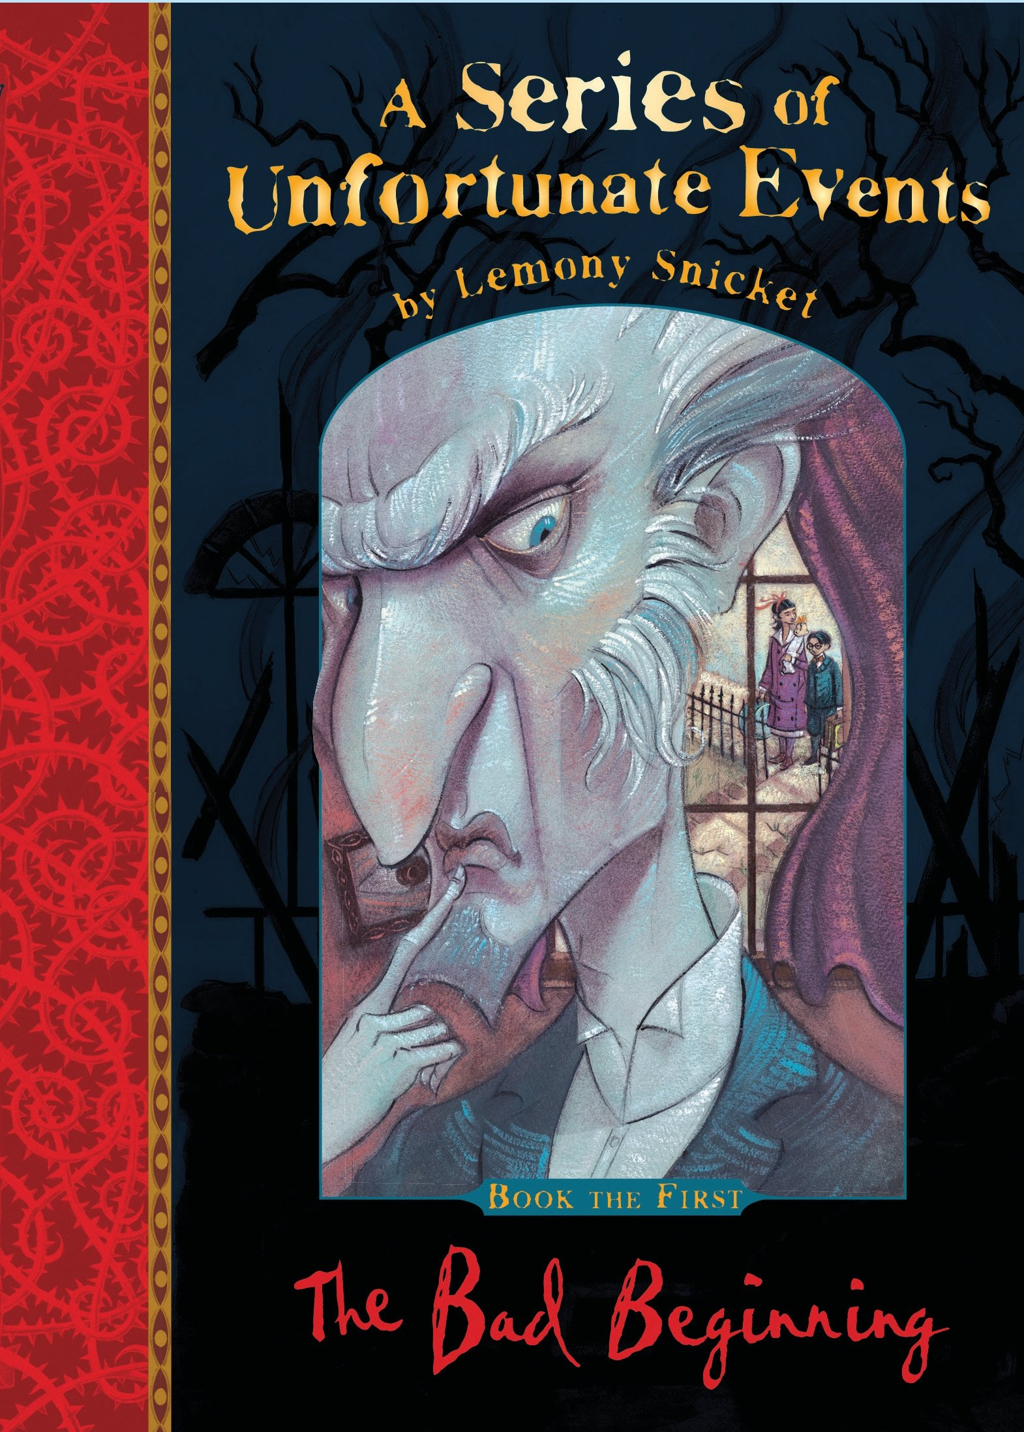

Autumn term: half term 2

***Year 5 Parent Communication***

