**Home Learning**

Reading books – To be returned every **Monday** to be swapped. If children are still reading the same book then books may remain at home but reading record sheets **need** to be returned weekly. Reminder letters will be issued by Mr Eaton, with 3 non-returns being reported to Mr Connolly.

Spellings: New spellings on a **Friday** and the test will be the following **Friday**. These will be on EdShed to practice, and also include a short word activity task to complete in homework books.

Maths: TT Rockstars for 30 minutes.

**Outside of the classroom …**

**Times Tables Rockstars**: *Mrs Taylor* (drop in, Fri Lunch)

**Homework:** *Mrs Taylor* (Thursday lunch, as needed)

**Crochet Club:** *Mrs Smith* (Monday, after school)

**Arts & Crafts Club**: *Mrs Torrington* (Thu, after school)

**The Hut**: *Mrs Torrington* (Mon, Tue lunchtime)

**Dates for your diary:**

15th January 2024

**National Space Centre Visit**

8am start – 5.30/5.45pm return

Fri 26th January

WWII Enrichment project due in school

**Friday 9th February 2023**

Last day of term & French Day

*Future dates:*

**Tue 20th February 5.45pm**

Thornbridge Parents’ meeting

**6th – 8th March**

**Thornbridge Residential**

**5pm Tue 26th & 4pm Thu 28th March**

Parents’ evening

**Our** **Learning this half term…**

|  |  |
| --- | --- |
| Reading | **Letters From The Lighthouse** |
| Writing | **Biography:** the life of the Venerable Bede  **Fact files**: The Planets of our Solar System |
| Maths | **Multiplication and division:** Using formal and mental methods  **Fractions and Fluency in written methods:** We will be learning about equivalent fractions, mixed and improper fractions, adding, subtracting and multiplying fractions and finding fractions of amounts. We will also be continuing to gain accuracy in calculating using written methods. |
| Science | **Earth and Space:** How our planet is part of the Solar System and key features relating it to other astronomical objects. |
| History / Cross-curricular | **The Riddle of Robin of Loxley:** Cross-curricular unit study with Geography, Science, Art and Music looking into the reality of Robin of Loxley, our community’s heritage, and its place in the legend of Robin Hood. |
| RE | **How do people’s beliefs about God, the world and others have impact on their lives?** |
| Art | **Illuminated Letters** (links to Bede writing unit) & **Sketching Nature** (links to Robin of Loxley work) |
| Computing | **Networks and the internet** |
| PE | **Hockey**: Children will be working on skills and playing full games. This will be outside PE – please provide children with trousers and a jumper for PE  **Dance** |
| Music | **Clarinets with Mr Martin** |
| French | **Family & Friends** |

Subjects in black will be taught by Mr Eaton, and purple by Mr Nuttall.

**Our class reader this term is:**

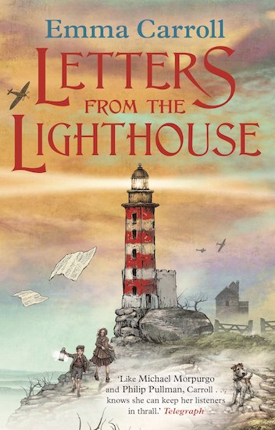

Spring term: half term 1

***Year 5 Parent Communication***

