**Our** **Learning this half term…**

|  |  |
| --- | --- |
| Reading | **Selected poetry and short texts for comprehension** |
| Writing | **Consolidating all SPaG learning up to Y5**  **When We Were Warriors: Olive’s Army** Writing a historical diary entry |
| Maths | **Fractions, decimals and percentages**: Conversion and fluency (continued from Spring 2)  **Decimals:** Addition, subtraction and multiplication of decimals and associated word problems / fluency  Identifying shape: Including triangles, angles, using a protractors and identification of quadrilaterals or irregular polygons |
| Science | **The Circulatory System**: how our body reacts to exercise and links with the circulatory system (continued from Spring 2) |
| History | **Settlers & Invaders part 2:** The Vikings |
| Geography | **Scandinavia and it’s People** |
| RE | **Sacred Places and their worship (Christianity and Buddhism)** |
| DT | **Gears, Mechanisms and Pulleys:** Preparation for building a model carousel in summer 2, including product design, research and practice modelling using 3D nets |
| Computing | **Graphical Modelling:** Using SketchUp (continued from Spring 2)  **Decisions and inputs**: Using Scratch as a means to programme |
| **PE** | **Athletics**  **Rounders** |
| Music | **Clarinets with Mr Martin** |
| French | **School Life** |

Subjects in black will be taught by Mr Eaton, red will be taught by Mrs Torrington and purple by Mr Nuttall

**Home Learning**

Reading books – To be returned every **Monday** to be swapped. If children are still reading the same book then books may remain at home but reading record sheets **need** to be returned weekly. Reminder letters will be issued by Mr Eaton, with 3 non-returns being reported to Mr Connolly.

Spellings: New spellings on a **Friday** and the test will be the following **Friday**. These will be on EdShed to practice, and also include a short word activity task to complete in homework books.

Maths: TT Rockstars for 30 minutes.

**Outside of the classroom …**

**Times Tables Rockstars**: *Mrs Taylor* (drop in, Friday Lunch)

**Athletics:** Mr Nuttall (after school ,Wednesday)*

**Crochet Club:** Mrs Smith (after school, Monday)*

**Craft Club**: Mrs Torrington (after school, Thursday)*

**Homework Club**: Mrs Taylor (drop in, Thursday lunch)

**The Hut**: Mrs Torrington (drop in, Tue & Fri lunches)

*prior sign up needed

**Dates for your diary:**

Mon 6th May

**May Day Bank Holiday**

Mon 20th – Thu 23rd May

**LOXLEY HEALTH WEEK:**

Please attend school in PE kit

Thu 23rd May

**Sports Day** (9.15am start for races)

**Last day of term**

Fri 24th May

**Staff Training INSET day (no school for pupils)**

**Our class reader this term is:**

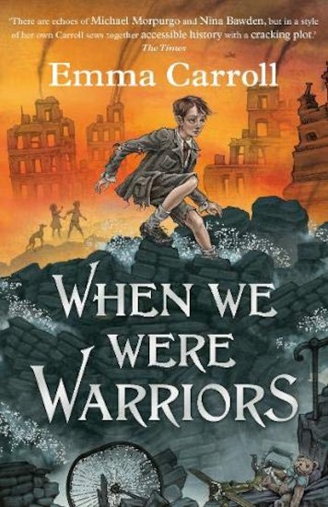

Summer term: half term 1

***Year 5 Parent Communication***

